HISTOGRAM AND DENSITY PLOT - UNITS CONSUMED
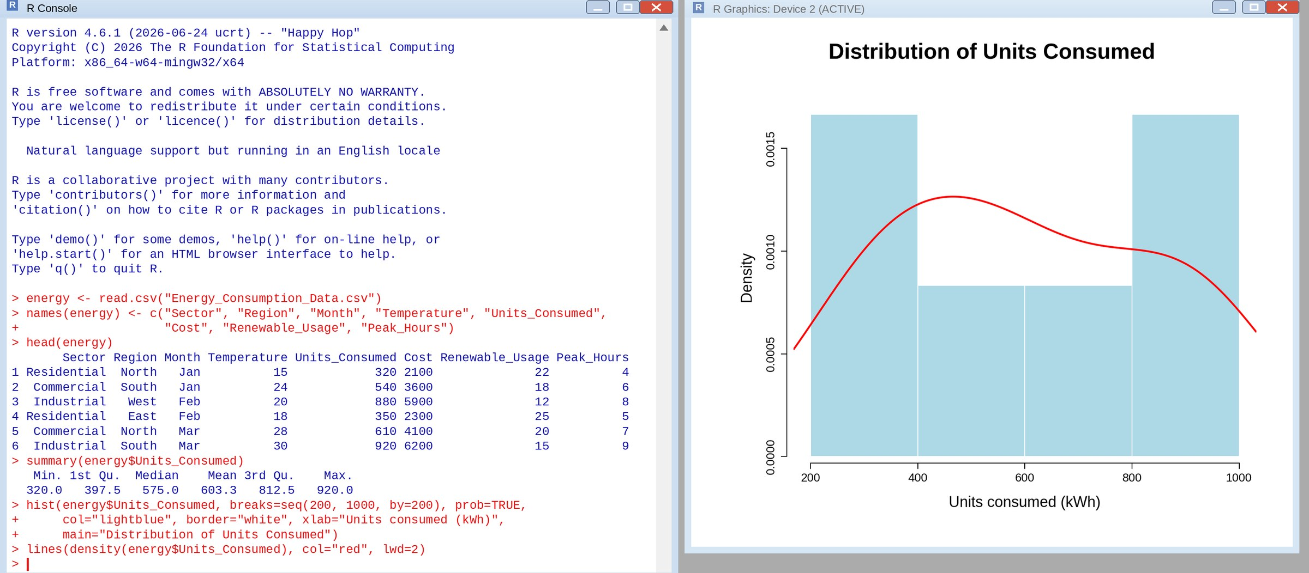
Comparison of consumption patterns: Units consumed range from 320 to 920 kWh. The mean (603.3 kWh) is above the median (575 kWh), which shows a slight right skew. The histogram has 2 observations in 200–400, 1 in 400–600, 1 in 600–800 and 2 in 800–1000, so consumption is heavier at the two ends than in the middle. The density curve smooths this into one broad hump peaking near 466 kWh with a long right shoulder up to about 920 kWh. With only six values and a bandwidth of about 160 kWh, the smoothing merges the separate groups, so the histogram is the better guide to the clusters.
Pattern by sector: The consumption pattern is driven by sector. Residential uses 320–350 kWh (mean 335), Commercial 540–610 kWh (mean 575) and Industrial 880–920 kWh (mean 900). Industrial consumption is about 2.7 times residential (900 / 335).
BUBBLE SCATTER PLOT - TEMPERATURE VS UNITS CONSUMED (BUBBLE SIZE = PEAK HOURS)
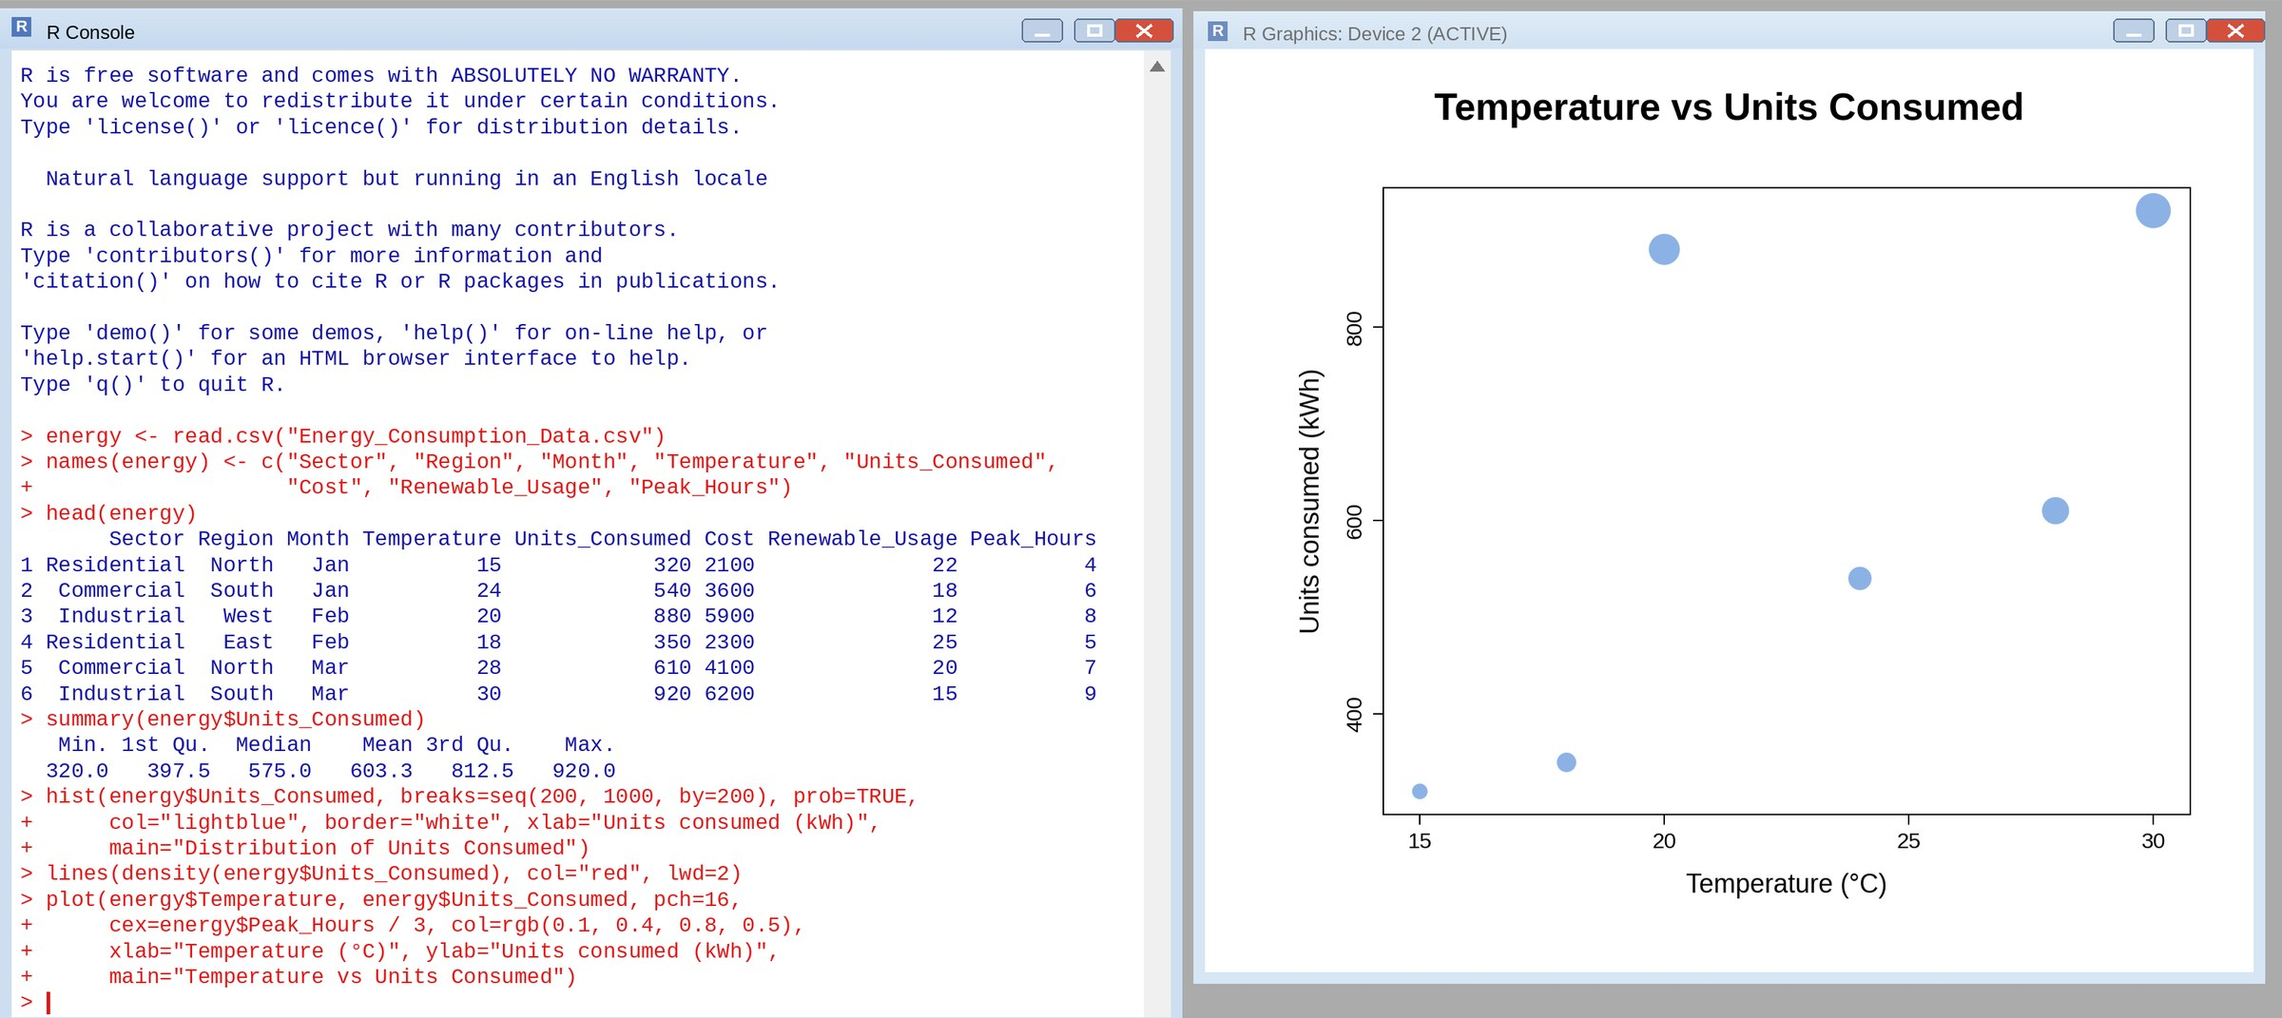
Interpretation: Units consumed rise with temperature (correlation r = 0.65, a moderate positive relationship): the 15 °C record uses 320 kWh and the 30 °C record uses 920 kWh. Bubble size shows peak hours, and the bubbles grow steadily from bottom-left to top-right (4 peak hours at 320 kWh up to 9 peak hours at 920 kWh). Peak hours and units consumed are very strongly related (r = 0.98), so heavy consumers are also the ones with the longest peak-demand periods. The transparency (alpha = 0.5) keeps overlapping bubbles visible. With only six records, and sector also influencing consumption, the temperature effect should be treated as indicative rather than proven.
BAR CHART - AVERAGE RENEWABLE USAGE BY SECTOR
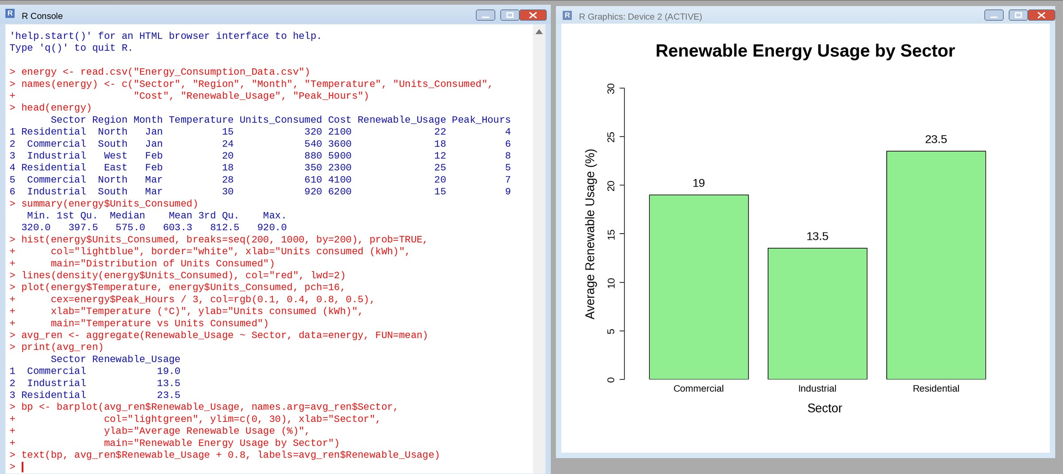
Interpretation of renewable energy adoption: Residential has the highest average renewable share (23.5%), followed by Commercial (19.0%) and Industrial (13.5%). Adoption falls as consumption rises: the average units consumed are 335 kWh (Residential), 575 kWh (Commercial) and 900 kWh (Industrial). The sectors that use the most electricity therefore have the lowest renewable share, so raising industrial adoption would have the largest effect on overall renewable use. Each sector average is based on only two records, so the result is a pattern to investigate further.
TABLEAU DASHBOARD - MONTHLY ENERGY USAGE TREND AND SECTOR-REGION HEATMAP
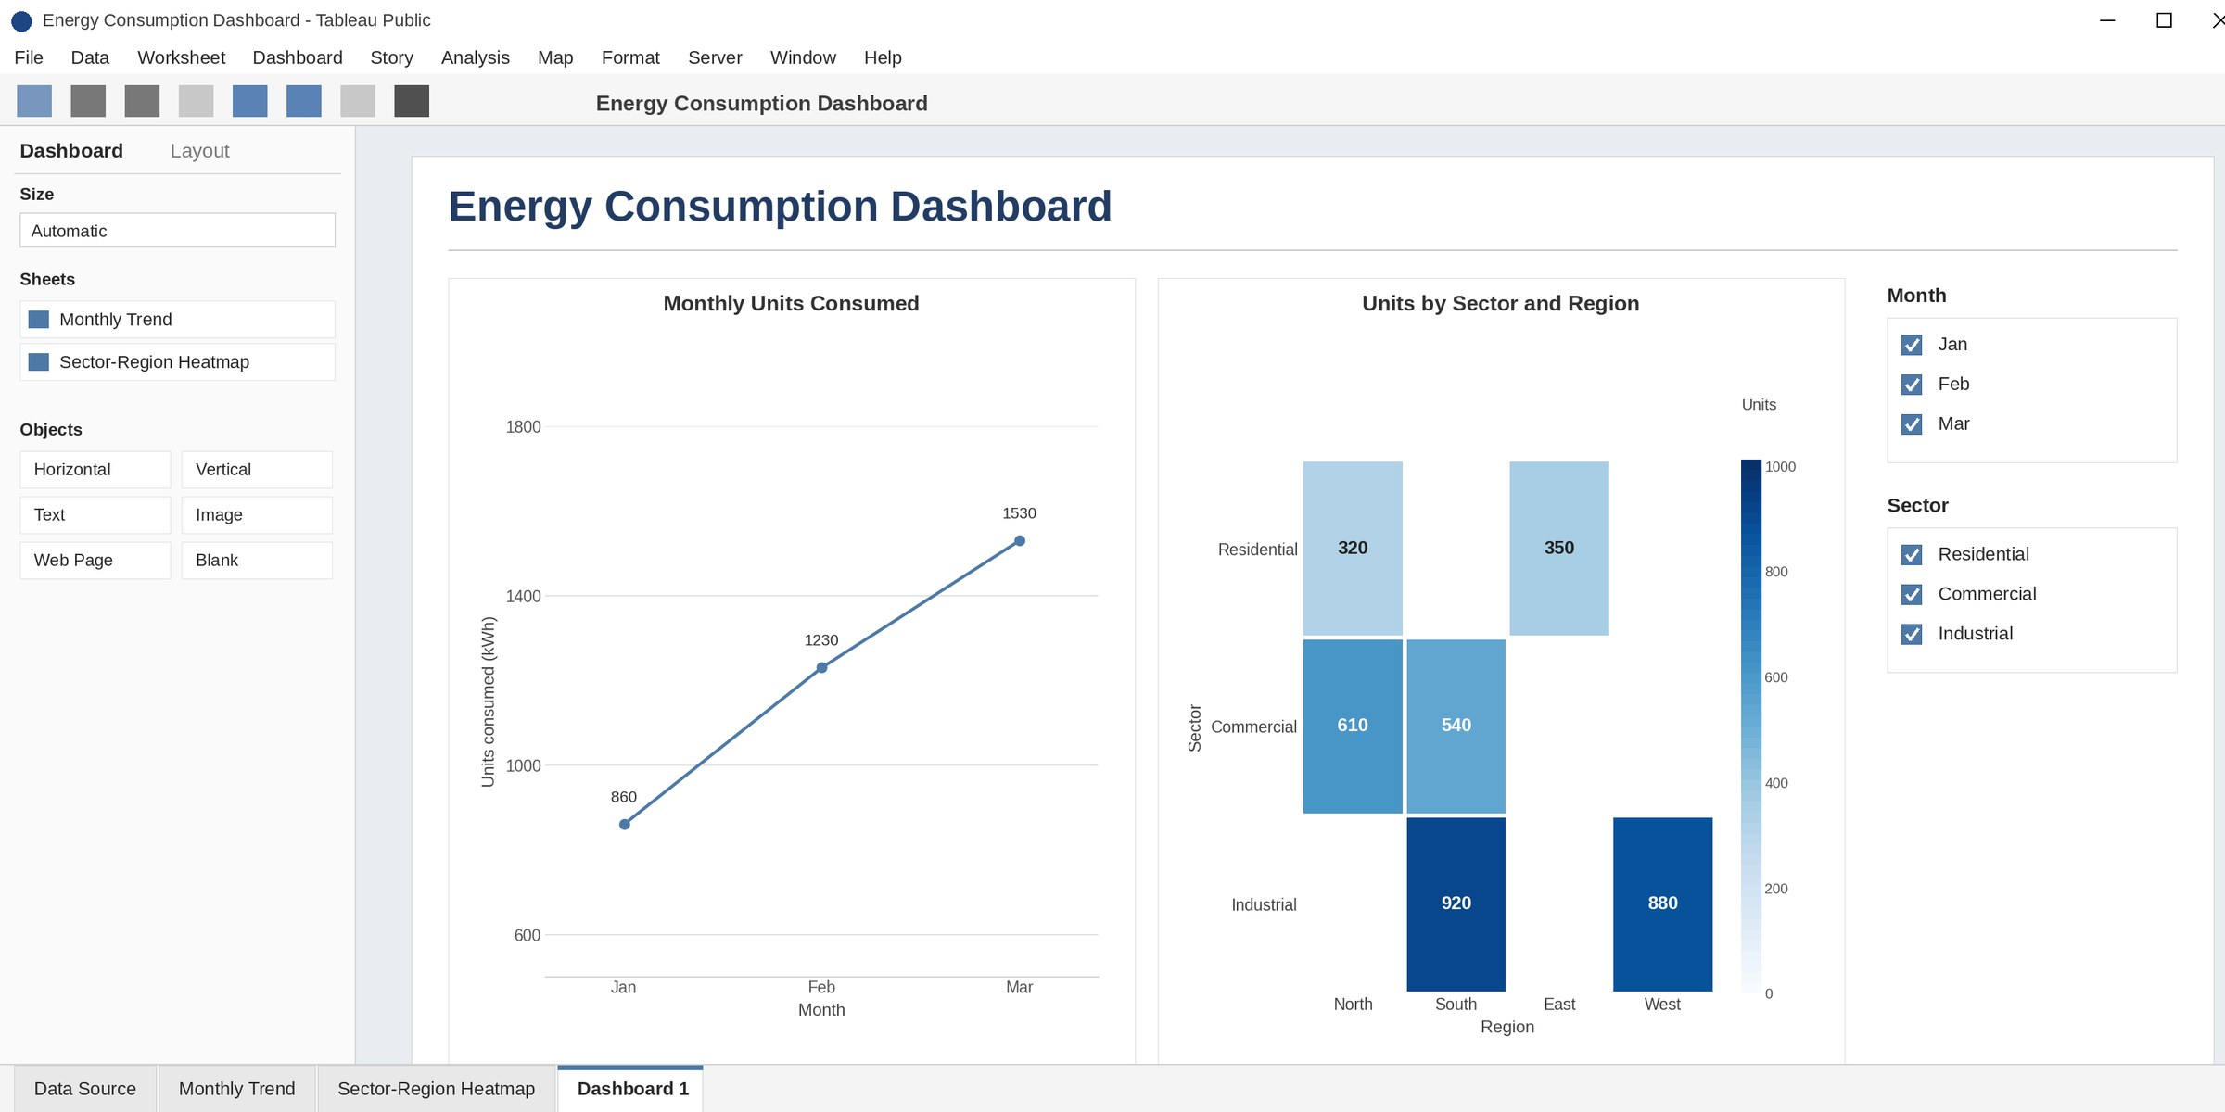
The line chart shows total units consumed rising each month (Jan 860, Feb 1,230, Mar 1,530 kWh). The heatmap shows units for each sector and region, with the darkest cells for Industrial (South 920, West 880). The Month and Sector filters let the user explore any combination.

